**Case Study – 6  
(40 points)**

**Name:**

**Clemson ID:**

**Submission**: Save this Word document with your answers as a PDF file and upload the PDF file to Canvas.

(10 pts) Build an object model for the Book Exchange Project. You should have a super-class, class and subclasses. Remember, we are modeling the system level objects not low-level software objects. Your objects need to have both methods and attributes. (Fig 6.1, Fig 6.2 & Fig 6.6)

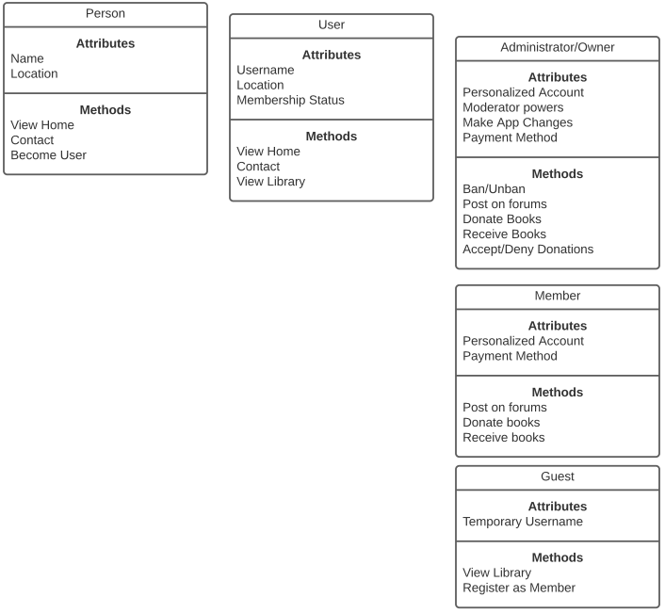

(10 pts) Build the class hierarchy diagram w/cardinality for the Book Exchange Project based on your object model above (Fig 6.17)

|  |  |  |  |  |
| --- | --- | --- | --- | --- |
| UML | Nature | Example | Example | Description |
| 0..* | Zero or many | Admin 1 | Ban Member 0..* | An admin can ban no or many members |
| 0..* | Zero or many | Member 0..* | Donate Books 0..* | Any number of members can donate any number of books |
| 1 | One and only one | Member 1 | Make account 1 | A member may only have one account |

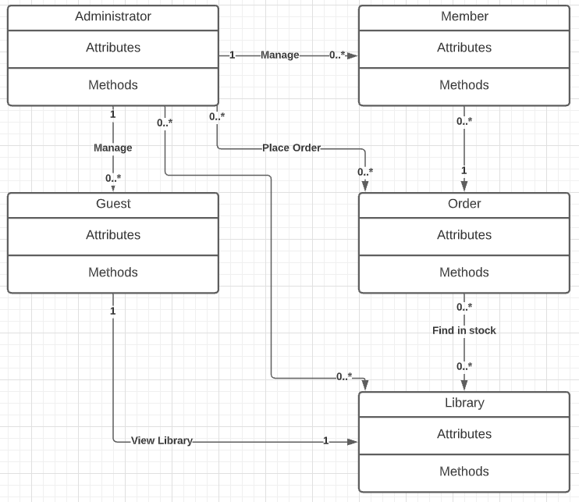

(10 pts) Build 2 use cases for the Book Exchange Project (Fig 6.15)

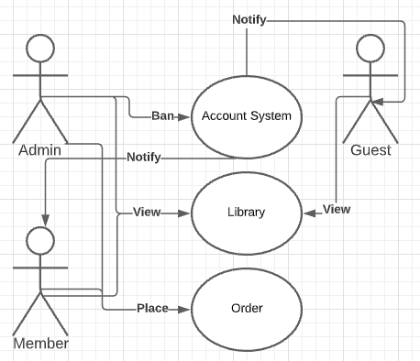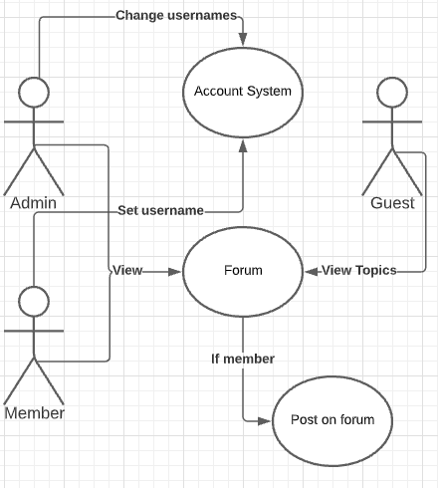

(10 pts) Build 2 state transition diagrams for the Book Exchange Project (Fig 6.20)

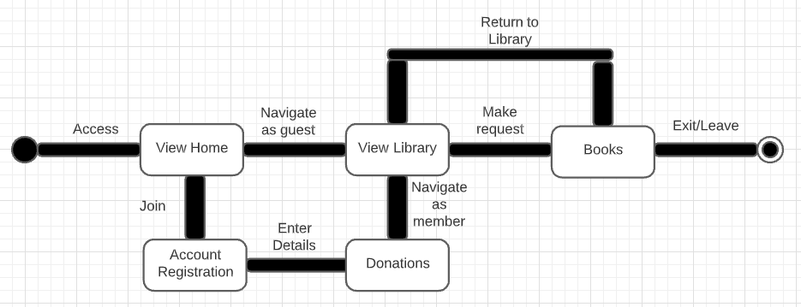

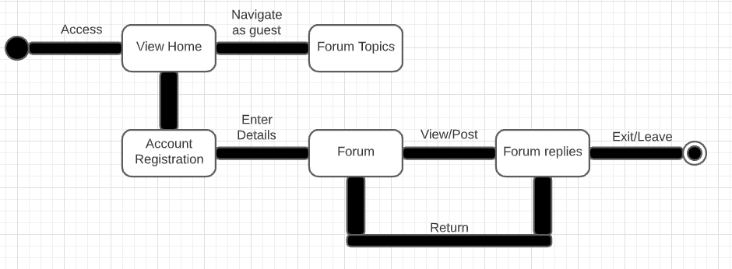

Use one of the diagramming tools identified on the “External Tools Page” in Canvas.

More information on UML Class diagrams can be found at O’Reilly Learning in *UML Distilled: A Brief Guide to the Standard Object Modeling Language*, by Martin Fowler.